**Assignment 33.2**

Problem Statement:

● Integrate Hbase with Hive

● Load Data (Bulk Load) from Hive table to Hbase Table

● Explain the procedures and code implemented with screenshots.

● Note: Candidates should Load their own data into Hbase table.

Create the HBase table employee with two column families personaldetails and deptdetails.

Insert the data into Hbase table

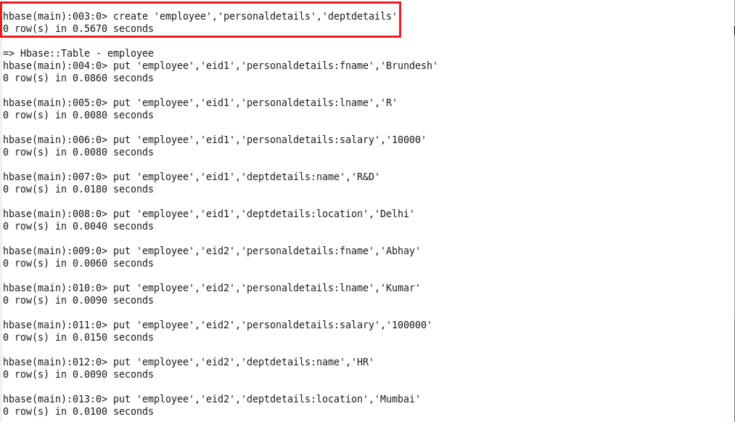

Create the hive table pointing to hbase table for column family personaldetails.

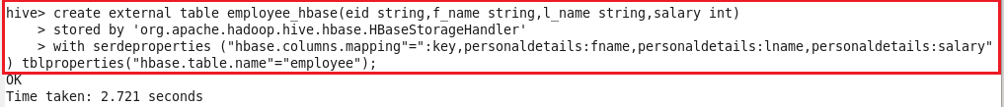

Displaying the contents of hive table.



Cretae hbase table and scan the table(no data is loaded)

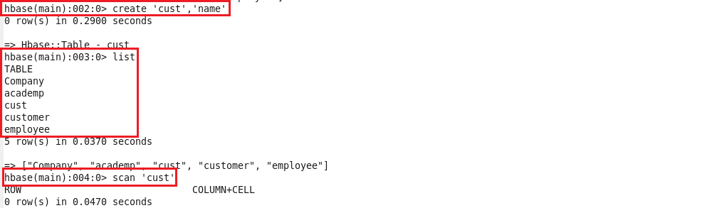

Create a hive table,load data in it and display the contents.

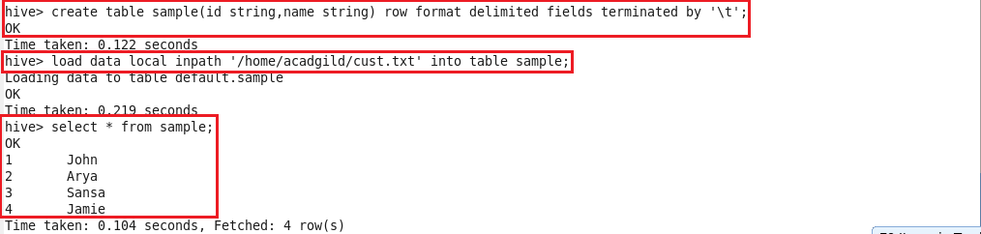

Create external table and the loading the data from the above table:

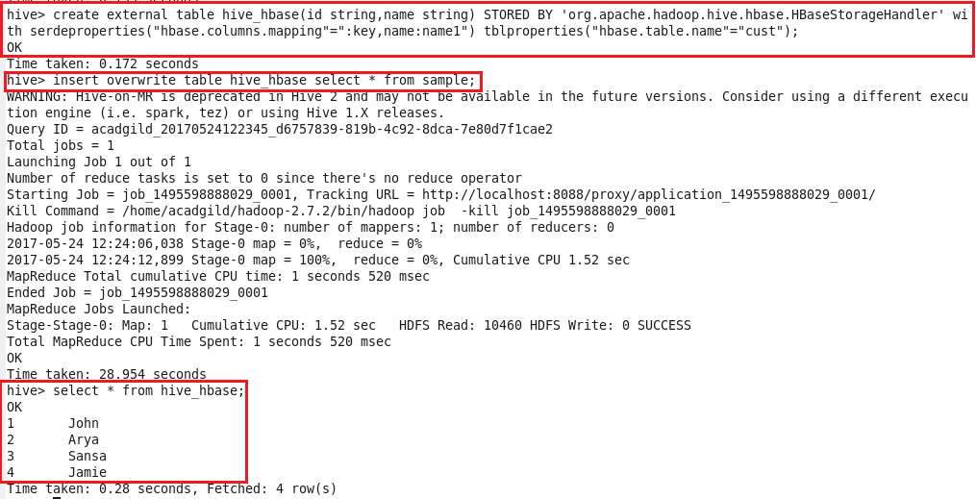

Now when we scan hbase table data will be loaded in it.

